**DDL: Create Database**

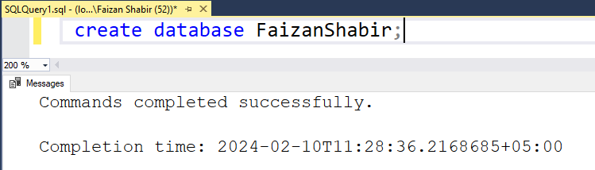

**DDL: Drop Database**

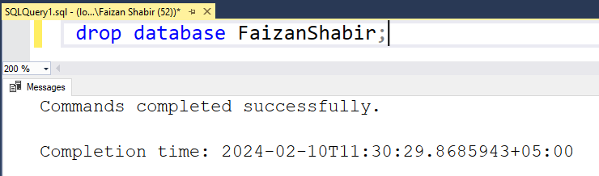

**Use Database**

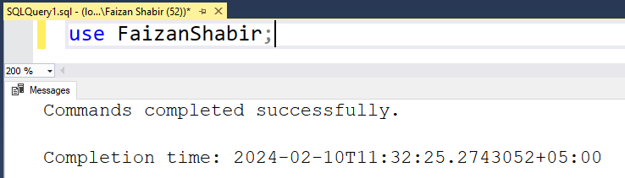

**DDL: Create Table**

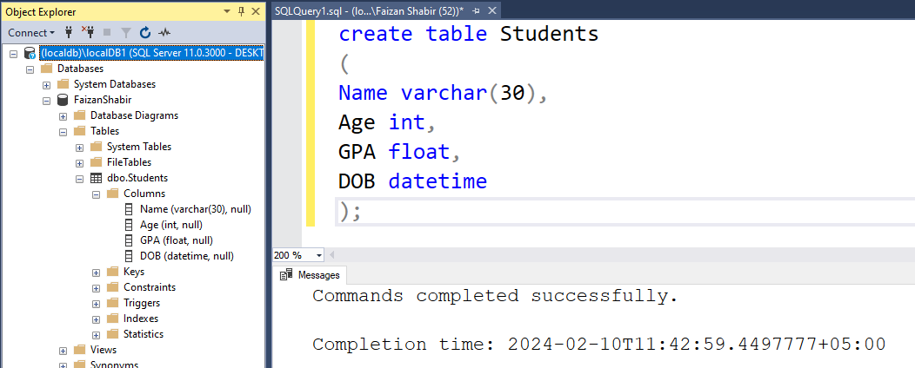

**DDL: Alter, Adding new column to existing table**

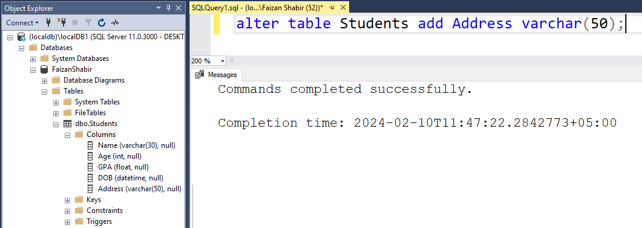

**DDL: Alter, Drop existing Column from existing table**

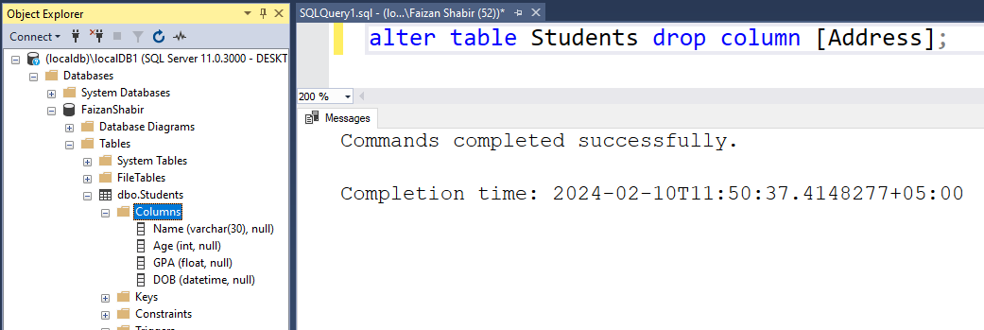

**DDL: Adding Primary Key while Table creation**

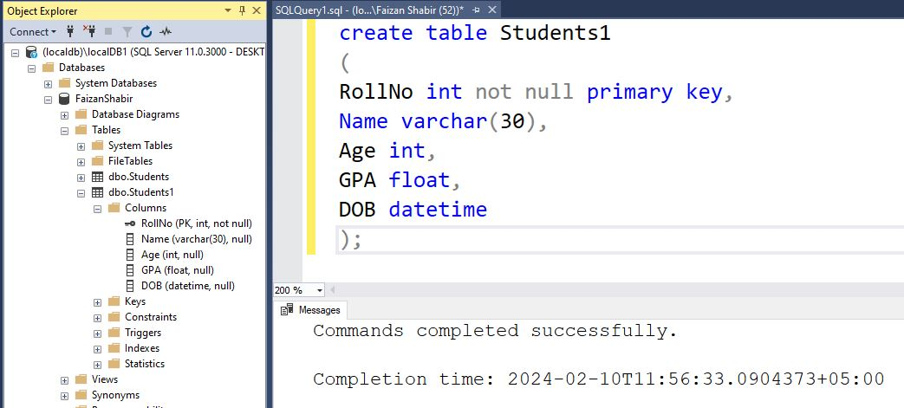

**DDL: Adding Composite Primary Key while Table creation**

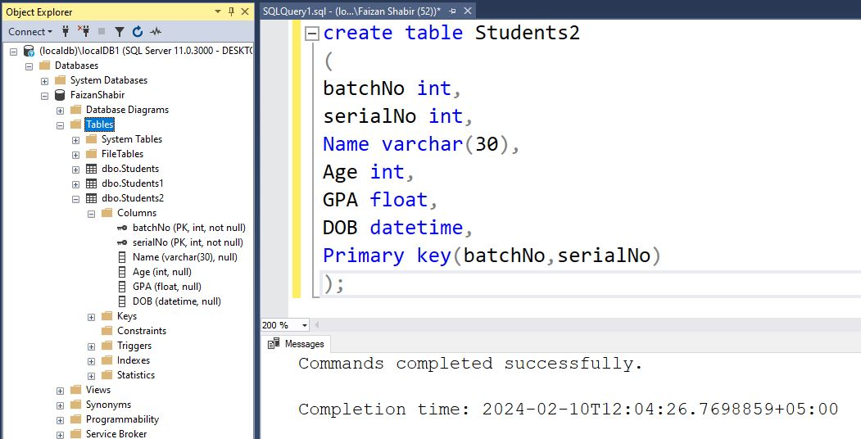

**DDL: Adding Primary Key after Table creation Using Alter query**

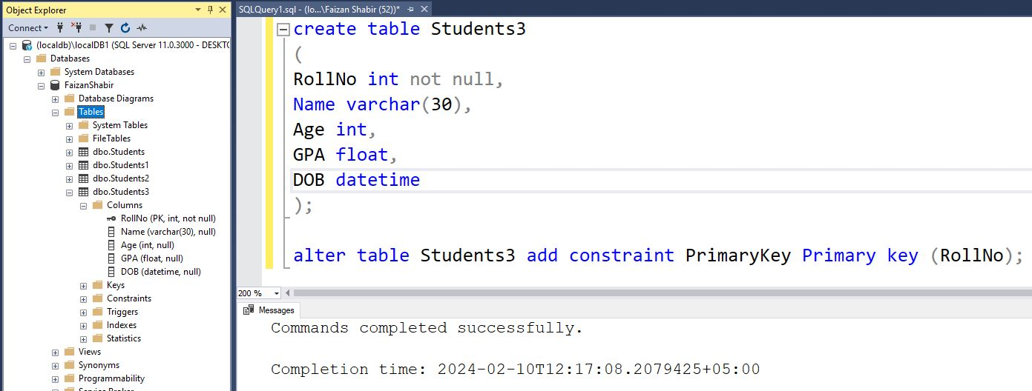

**Schema for ‘Students’ Table**

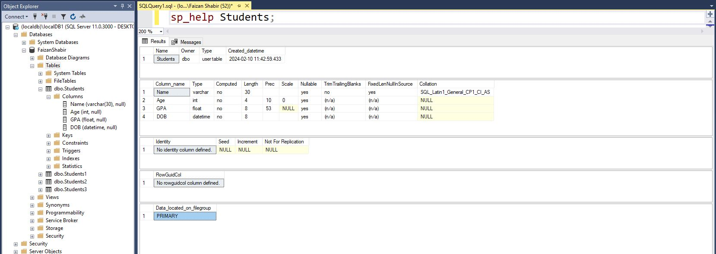

**Schema for ‘Students1’ Table**

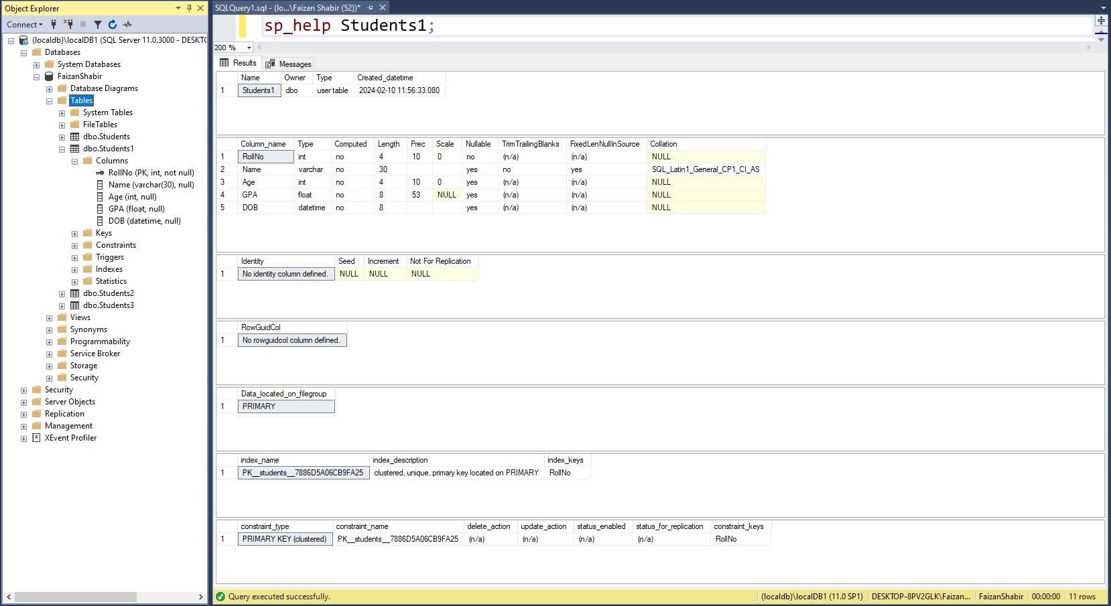

**Schema for ‘Students2’ Table**

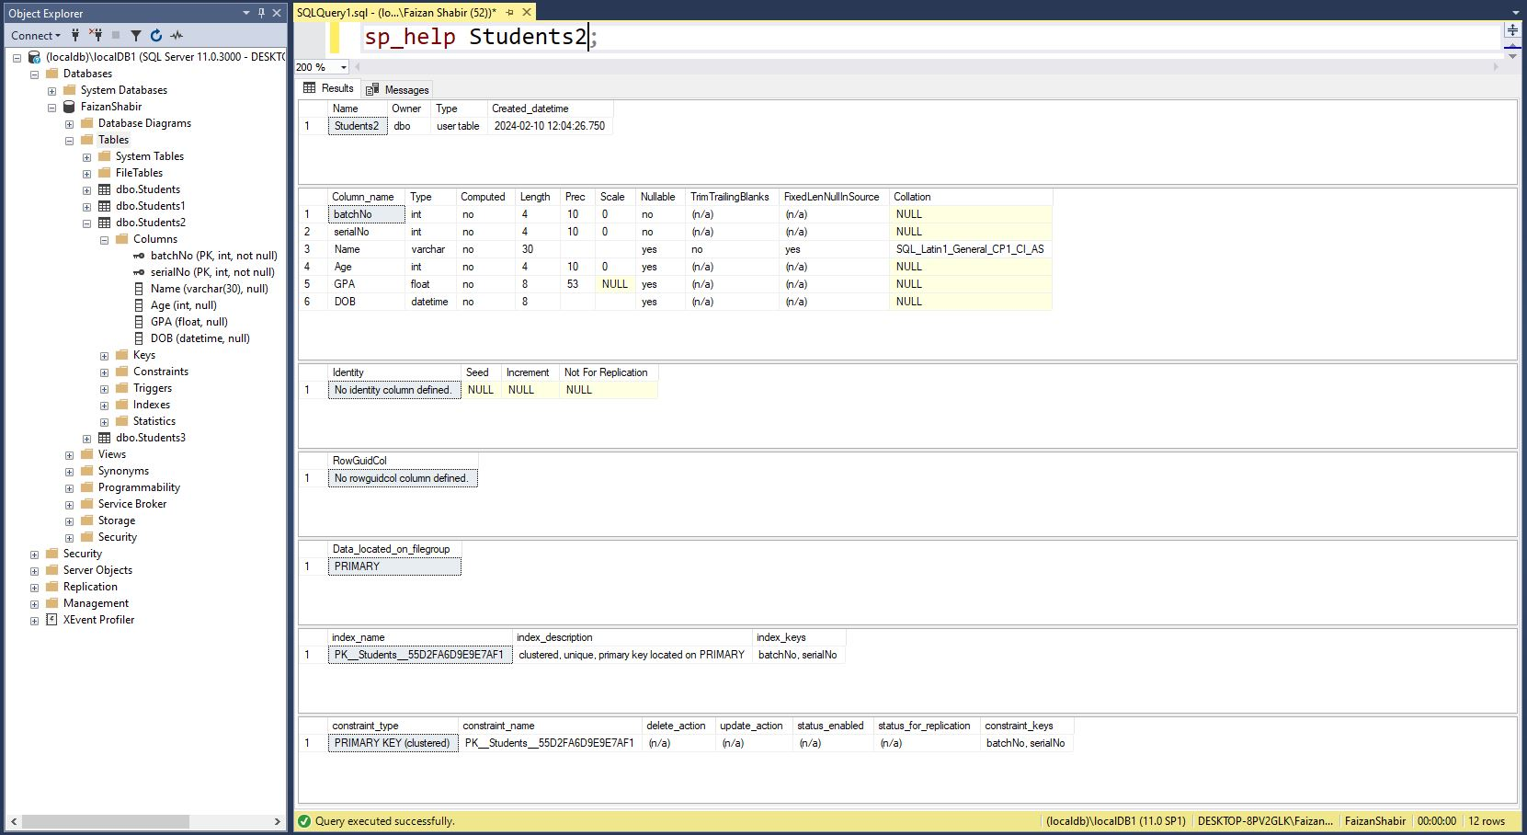

**Schema for ‘Students3’ Table**

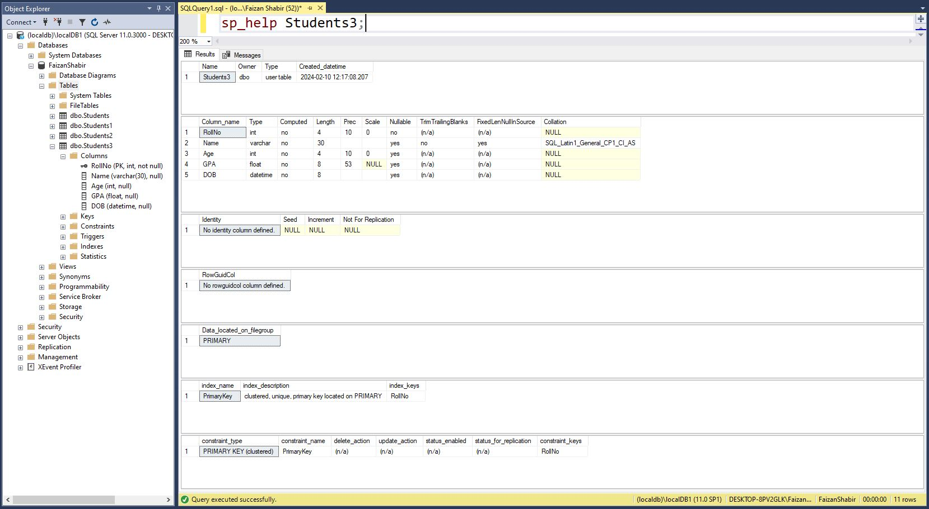

**DDL: Adding Foreign Key while Table creation**

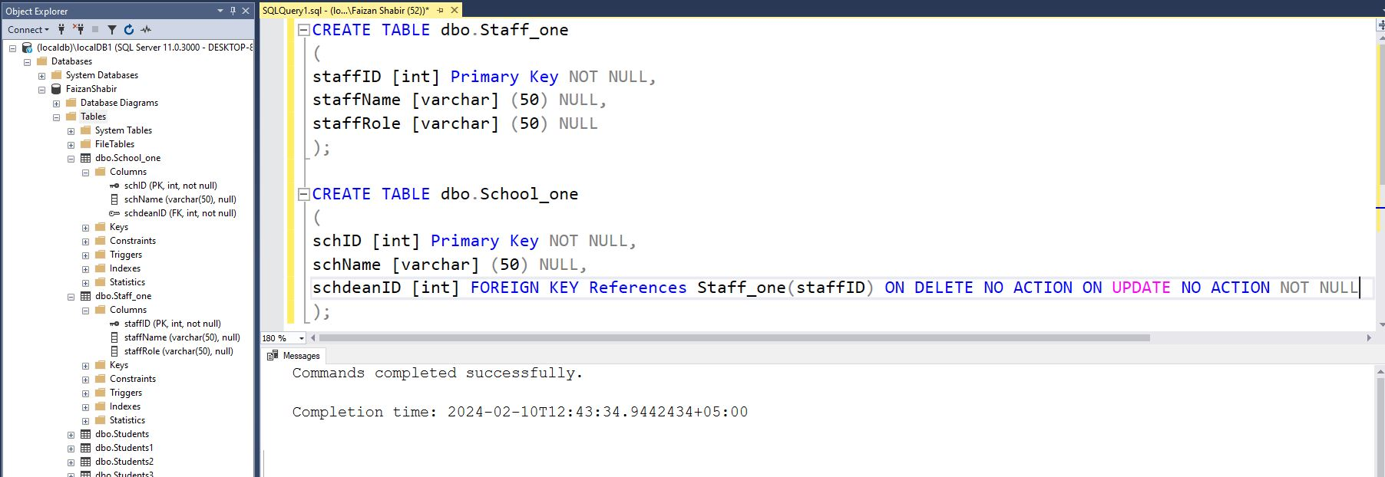

**DDL: Adding Foreign Key after Table creation**

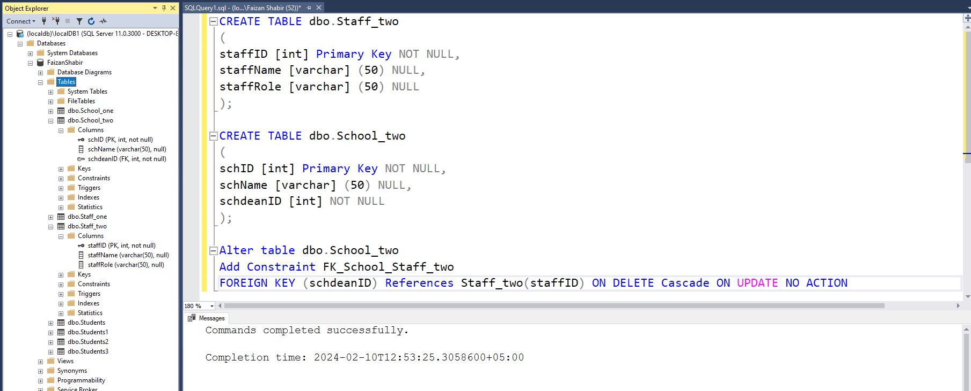

**DML: Inserting a complete row into the ‘Students1’ table**

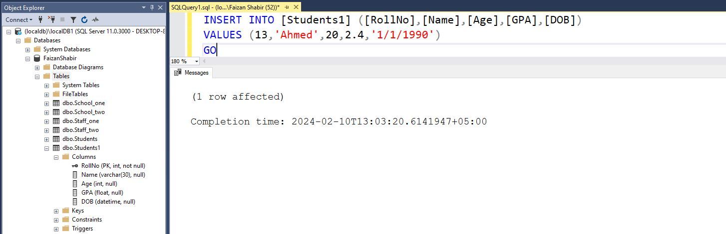

**DML: Inserting an Incomplete row into the ‘Students1’ table**

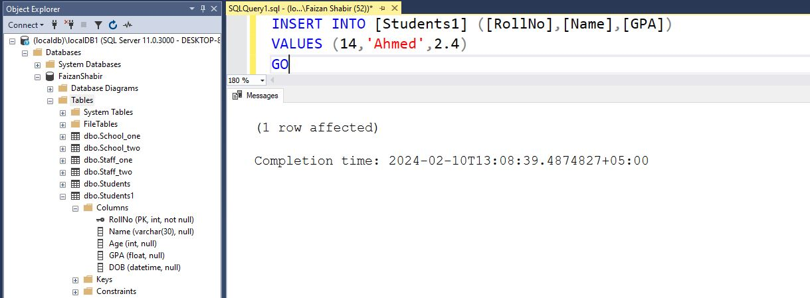

**DML: The ‘Students1’ table after insertion of some data**

